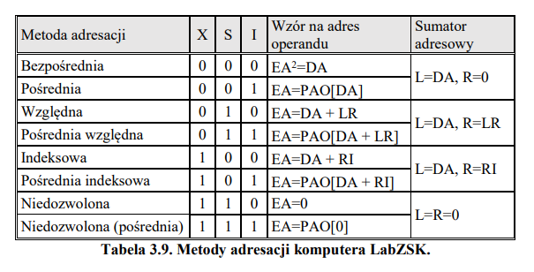
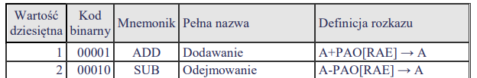

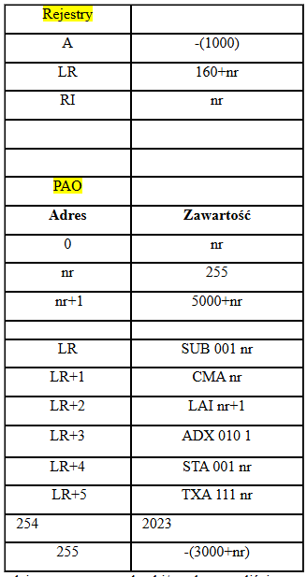
ZWYKŁY ROZSZERZONY
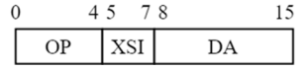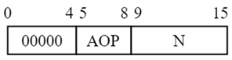

NR=10

CMA 10
N=10
PAO[N]=PAO[10]=255
RAE=PAO[N]=255
LR=171 (LR=170+1)
A=-A=1000

SUB 000 10
XSI=000 (L=DA, R=0)
DA=10
RAE=DA+0, wiec u nas RAE=10+0
LR=171 (LR=170+1)
A=A-P[RAE] A=-1000-P[RAE]=-1000-P[10]=-1000-255=-1255

SUB 001 10
XSI=001 (L=DA, R=0)
DA=10
PAO[DA]=PAO[10]=255
RAE=PAO[DA]=255
LR=171 (LR=170+1)
A=A-P[RAE] A=-1000-P[RAE]=-1000-P[255]=-1000+3010=2010

SUB 010 10
XSI=010 (L=DA, R=LR)
DA=10; LR=170
RAE=DA+LR, wiec u nas RAE=10+170
LR=171 (LR=170+1)
A=A-P[RAE] A=-1000-P[RAE]=-1000-P[180]=-1000

SUB 011 10
XSI=011 (L=DA, R=LR)
DA=10
PAO[DA+LR]=PAO[10+170]=PAO[180]
RAE=PAO[DA+LR]=PAO[180]=0
LR=171 (LR=170+1)
A=A-P[RAE] A=-1000-P[0]=-1000-10=-1010

SUB 100 10
XSI=100 (L=DA, R=RI)
DA=10; RI=10
RAE=DA+RI, wiec u nas RAE=10+10=20
LR=171 (LR=170+1)
A=A-P[RAE] A=-1000-P[20]=-1000-0=-1000

SUB 101 10
XSI=101 (L=DA, R=RI)
DA=10
PAO[DA+RI]=PAO[10+10]=PAO[20]=0
RAE=PAO[DA+RI]=PAO[20]=0
LR=171 (LR=170+1)
A=A-P[RAE] A=-1000-P[0]=-1000-10=-1010

SUB 110 10
XSI=110 (L=0, R=0)
RAE=0
LR=171 (LR=170+1)
A=A-P[RAE] A=-1000-P[0]=-1000-10=-1010

SUB 111 10
XSI=111 (L=0, R=0)
DA=10
PAO[0]=10
RAE=PAO[0]=10
LR=171 (LR=170+1)
A=A-P[RAE] A=-1000-P[10]=-1000-255=-1255

